# **KAVYA KUMARI RALLAPALLI**

SESHADRI RAO GUDLAVALLERU ENGINEERING COLLAGE

**Data Analytics with Tableau**

23481A4249

**ASSIGNMENT 1:**

**Aim:** The growth of supermarkets in most populated cities is increasing and market competitions are also high. The dataset is one of the historical sales of supermarket company which has recorded in 3 different branches for 3 months data.

**CREATE BELOW VISUALIZATION:**

1. **PIE CHART:**

**TITLE: INCOME WITH PRODUCT LINE**

**C: Product line**

**R: Income**

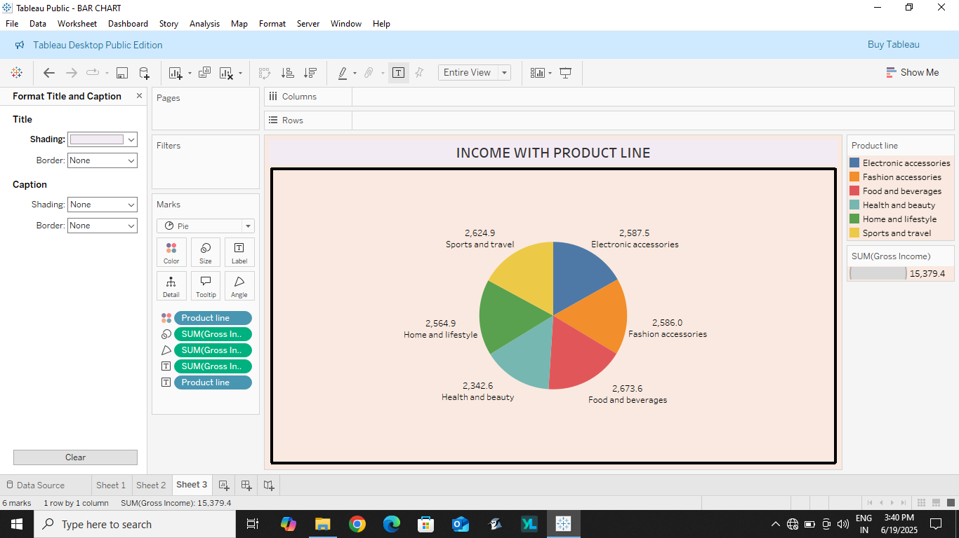

1. **BAR CHART:**

**TITLE: GROSS INCOME BY CUSTOMER TYPE**

**C: Customer type**

**R: Sum (Gross Income)**

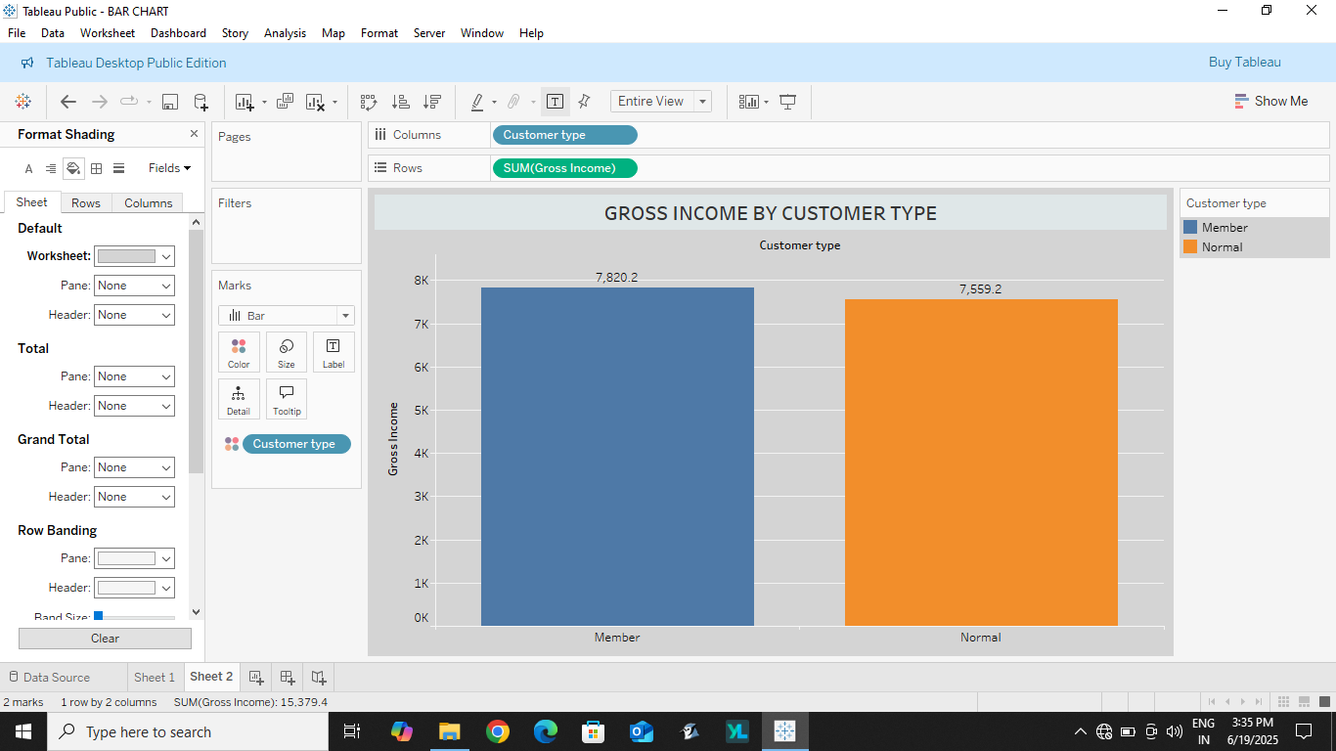

1. **STACKED BAR CHART:**

**TITLE: GROSS INCOME BY PRODUCT LINE**

**C: Product line**

**R: Gross income**

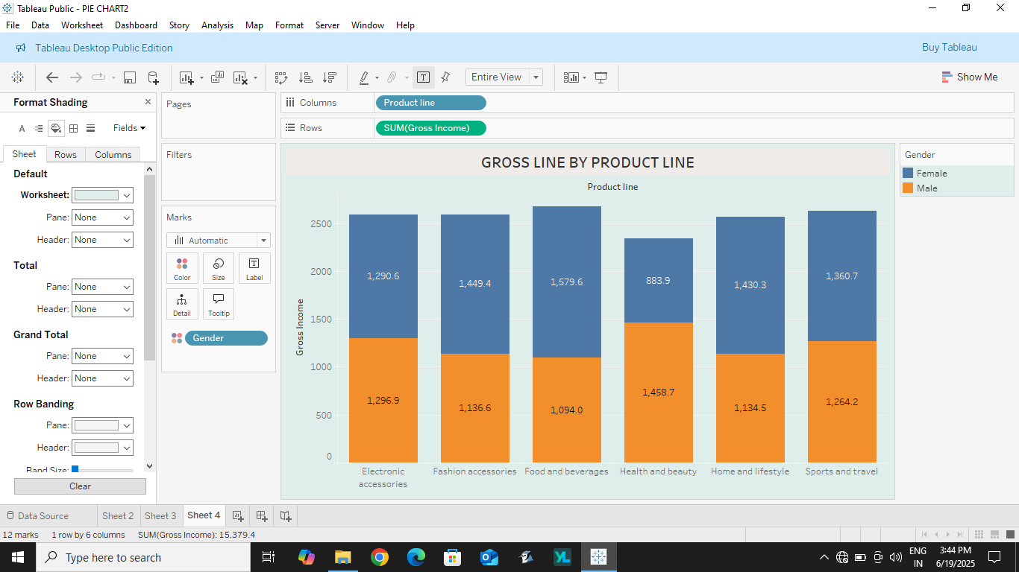

1. **LINE CHART:**

**TITLE: GROSS INCOME WITH TIME**

**C: Time**

**R: Income**

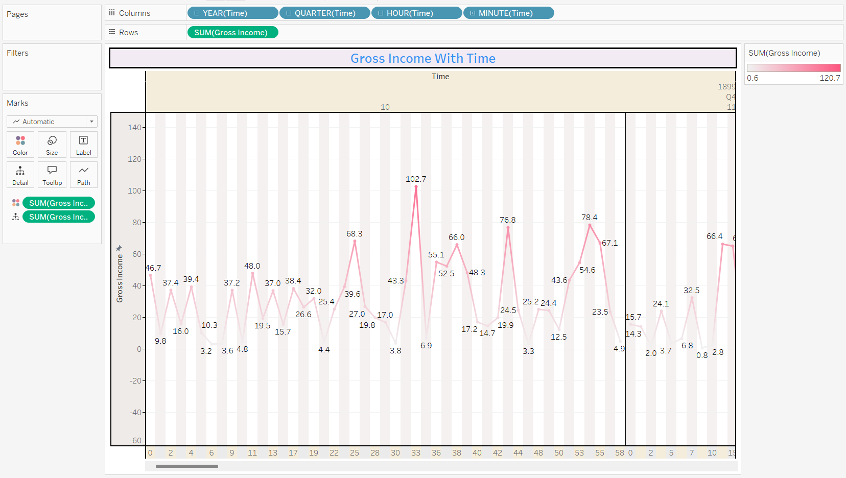

5**. BUBBLE CHART:**

**TITLE: QUANTITY WITH PRODUCT**

**C: Product**

**R: Quantity**

